Year 8 Level 5 Practice Assessment

Name: Class: Date:

A(7) B(10) C(14) D(7) Total Score (38) Level

A Counting and understanding numbers:

1. 3.7 ÷ 100
1 mark (L5/1)

2. Round the following to one decimal place.
2.48 5.26 7.22 4.66 3.91

2 marks (L5/2)

3. Use each of the numbers 1, 2, 3, 4 and 5 to correctly complete the following sentences:
___ is a factor of ___
42 is a multiple of ___
___ is a prime number
___ is not a prime number

2 marks (L5/3)
4. Complete these fractions to make each equivalent to ³⁄₄
8
1
2
1
2
1 mark (L5/4)
5. Write ⁴⁄₁₆ in its simplest form
1 mark (L5/5)

B Calculating

6. Write in the missing numbers.
÷ 22.6 = 7.5
1 mark (L5/6)

50 – (14.24 + 16.36) =
1 mark (L5/6)

7. Write in the missing numbers (you may use a calculator).3
45% of 80 is
1 mark (L5/7)
45% of is 80
1 mark (L5/7)

8. Calculate 346 x 23
2 marks (L5/8)

9. Write a number in each box to make the calculations correct.
+ = -8
- = -8

2 marks (L5/9)

10. Here is a recipe for raspberry ice cream.
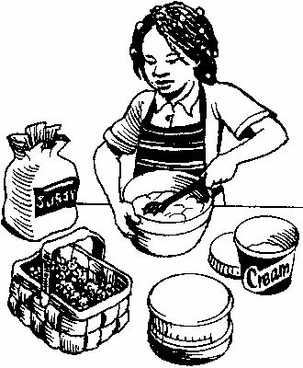
This recipe is for 8 people.
Josie makes enough raspberry ice cream for 12 people.
How much cream does she use?
litre
1 mark (L5/10)

11. Sue thinks of a number.
She divides it by 6 then adds 9. Her answer is 20.
What is the number Sue thinks of?

1 mark (L5/11)
C Shape, Space and Measure
12. Here are four statements.
For each statement put a tick () if it is possible.
Put a cross () if it is impossible.
A triangle can have 2 parallel sides.
A triangle can have 2 perpendicular sides. 1 mark (L5/12)
A triangle can have 2 acute angles.
A triangle can have 2 obtuse angles. 1 mark (L5/12)

13. Draw all lines of symmetry on the shape below. 1 mark (L5/13)
What order of rotational symmetry does the shape have?
1 mark (L5/13)
14. Work out the size of the missing angle marked ‘m’

m

62
1 mark (L5/14)
15. Here is a triangular box.
Below is part of the net of the box, but two of its faces are missing.
Draw accurately, full size, ONE of the missing faces on the diagram below.

You can use a ruler and protractor (angle measurer).

2 marks (L5/15)
16. This is a design for an arrowhead.
Below is part of a larger scale drawing of the arrowhead. The drawing has the same size angles as the design.

Draw two more lines to complete the arrowhead accurately. Use an angle measurer (protractor).

2 marks (L5/16)
17. Here is some flour on a weighing scale.

How many grams of flour are on the scale?
grams
1 mark (L5/17)

18. Complete the following:

2 metres = ...................cm
2.5 litres = ....................ml
1300 g = .................kg
1 mark (L5/18)
19. This shape is made from 4 shaded squares.
Calculate the perimeter of the shape.

2 marks (L5/19)

What is the area of the shape?
1 mark (L5/19)

D Data Handling
20. Here is a spinner
Anne spins the arrow.
What is the probability that the arrow stops in sector E?
Show this probability by putting a cross (X) on the probability line below.
1 mark (L5/20)
21. Write a different number in each of these boxes so that the mean of the three numbers is 8
1 mark (L5/21)

Write a number in each of these boxes so that the mode of the five numbers is 12.
1 mark (L5/21)
22. Mark throws a fair coin.
He gets a Head.
Mark’s sister then throws the same coin.
(a) What is the probability that she will get a Head?
.......................... 1 mark (L5/22)
Mark throws the coin 30 times.
(b) Explain why he may not get exactly 15 Heads and 15 Tails.
..........................................................................................................................................
.......................................................................................................................................... 1 mark (L5/22)

23. Tony and Gemma looked for snails, worms, slugs and beetles in their gardens.
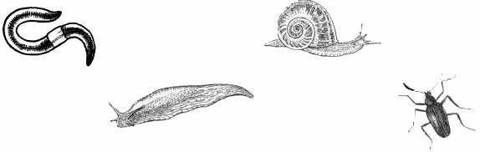
They each made a pie chart of what they found.

- Estimate the number of worms that Tony found. 1 mark (L5/23)

- Who found more snails?
Circle Tony or Gemma. Tony / Gemma
Explain how you know.
...................................................................................................................................................
....................................................................................................................................................
....................................................................................................................................................
1 mark (L5/23)

